Change Order Request

March 31, 2016

Chinn Construction, LLC
14715 NE 95th Street, Suite 101
Redmond, WA 98052
Attn: Charlie Poggemann

Re: Hadley Apartment Project – Change Order Request

Charlie,

Due to RFI-236, we will have to remove gas piping that was previously installed and reinstall per the new barbecue layout. Total cost is $723 + 10% OH&P = 795. Please let me know if you have any questions or comments. Thank you.

Sincerely,
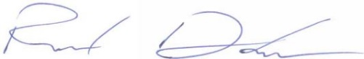
Richard Donelson
Project Manager / Estimator
LEED® Green Associate
richd@owpllc.net
425-591-4296 cell

